Notes from git-Course from Fattah Ben

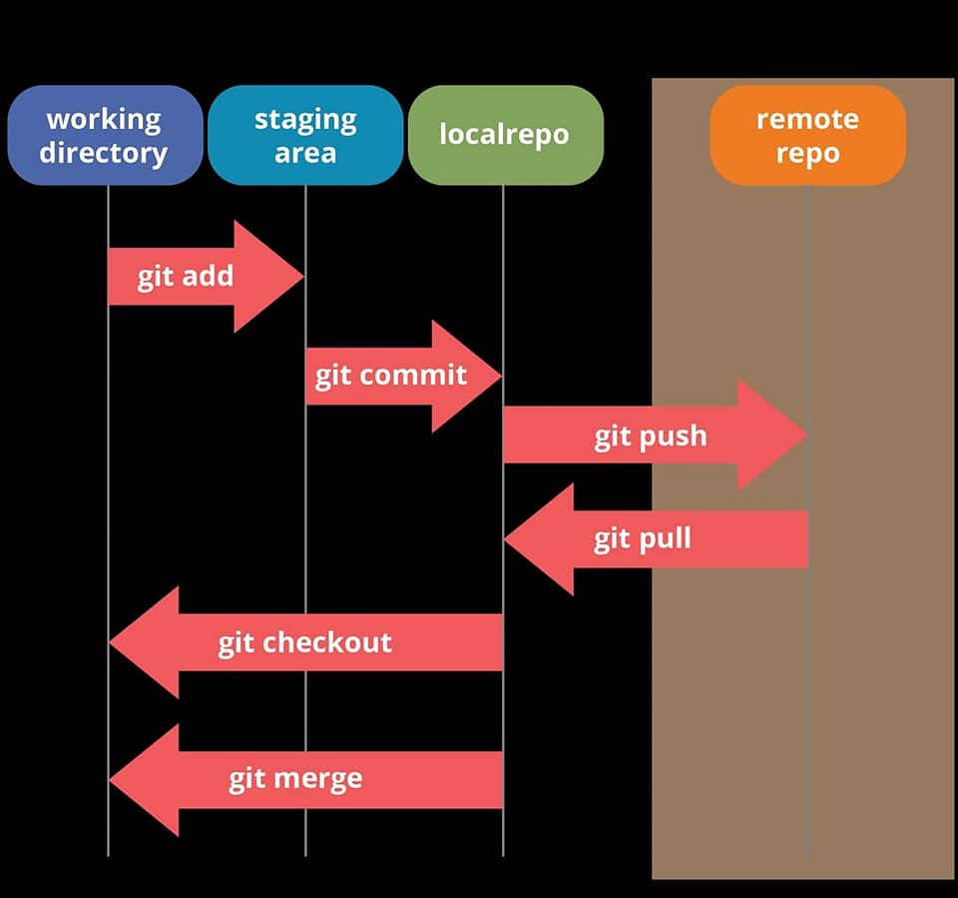

**Pull**: Download changes from the remote repo to your local repository.

**Push**: Upload changes made in your local repository to a remote repository.

**Commit**: Save changes made in RStudio to the local repository on your computer.

**Working directory must be initialised once using** *git init .***.,** *git init .* **is only used for brand new projects**

**If git bash is stack in master branch type the code below to move to normal window:**

** **

*rm -rf ~/.git*

**Steps in a Console to make changes to projects using git**

**Steps:**

**Global setting**

*git config --global user.name “bbbbbbbb”*- Creates a user name to be used

*git config --global user.email “bbbbb@bbb.com”*

To check details entered properly type: cat ~/.gitconfig

Add SSH key to git Account: Creates a signature key for PC as validation

* Type: *ssh-keygen -o*
* Press enter and no passphrase, enter again and generates your public key
* Type cat paste the the extension for public key begins with */c/User….pub*
* A key is generated. Copy the whole key and go to github under setting ssh section enter the key for a particular project

To change user.name: *git config -- global user.name “new_name”*

To create user name for all projects the command is: *git config --global user.name “bbbb”*

It’s also possible to have a user name for the local repo to a particular project only :

*git config -- local “James2”*

The same can be done for local email

*git config -- i* :Shows different configurations available in git

To select a project the command is: *cd git-course*

**Cloned a repo:**

*git clone git@github.com:wagtail/wagtail.git*

*git version*

*cd..*

*mkdir git-course*

*cd git-course*

*git-course>cd git-course*

*git-course\git-course>dir*

*git-course\git-course>explorer*

*git-course\git-course>git status*

*git-course\git-course>git commit -m "Created the Main structure of the project"*

*git-course\git-course>git status*

*git-course\git-course>git remote -v*

*git-course\git-course>git status*

*git-course\git-course>git push origin master*

*git-course\git-course>git status*

*git-course\git-course>^A*

**Modified css**

*git-course\git-course>git status*

*git-course\git-course>git add css\main.css*

*git-course\git-course>git status*

*git-course\git-course>git commit -m "modified the css file"*

*git-course\git-course>git push origin master*

*git-course\git-course>git status*

**Ignore some files**

Command: touch .gitignore

.gitignore –edit : Used to edit the ignore file

* git status

Create global ignore file

cd..

cd..

touch .gitignore_global

explorer .

git config - -global core.excludesfile ~/.gitignore_global

cd git-Course\repos\

git status

To view files in current directory use ls

*ls*

To open the directory folder type

*start . (*with space between word and fullstop)

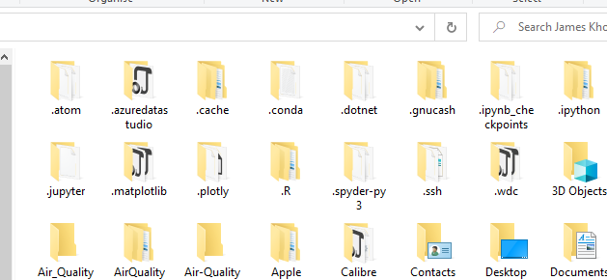

To open a specific folder we use its name

*$ ls Desktop*

To view a file/folder within the directory Desktop we use the following

*$ ls Desktop/00_Python_2021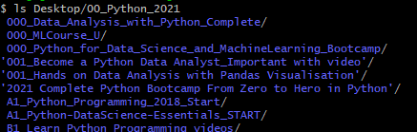*

pwd – Print working directory location

*$ pwd*

cd – Change directory

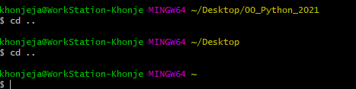

Terminal Creating files and Folders : *touch*

$ touch purple.txt

Multiple files

$ touch purple.txt orange.py yellow.pdf

**Creating Folders used mkdir**

*$ mkdir* 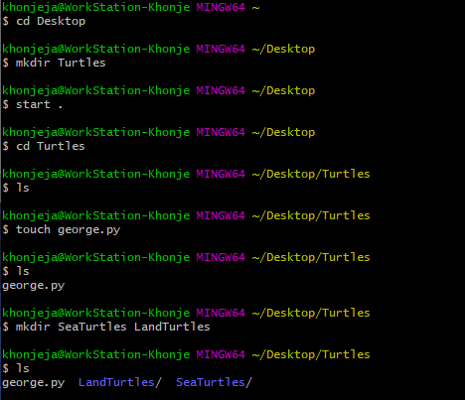

khonjeja@WorkStation-Khonje MINGW64 ~/Desktop

$ cd Turtles

khonjeja@WorkStation-Khonje MINGW64 ~/Desktop/Turtles

$ ls

khonjeja@WorkStation-Khonje MINGW64 ~/Desktop/Turtles

$ touch george.py

khonjeja@WorkStation-Khonje MINGW64 ~/Desktop/Turtles

$ ls

george.py

khonjeja@WorkStation-Khonje MINGW64 ~/Desktop/Turtles making 2 directories

$ mkdir SeaTurtles LandTurtles

khonjeja@WorkStation-Khonje MINGW64 ~/Desktop/Turtles

$ ls

khonjeja@WorkStation-Khonje MINGW64 ~/Desktop/Turtles

$ rm george.py

khonjeja@WorkStation-Khonje MINGW64 ~/Desktop/Turtles

$ ls

**To delete a folder we us rm -rf LandTurtles**

khonjeja@WorkStation-Khonje MINGW64 ~/Desktop/Turtles

$ ls -a

./ ../ LandTurtles/ SeaTurtles/

khonjeja@WorkStation-Khonje MINGW64 ~/Desktop/Turtles Deleting directories

*$ rm -rf LandTurtles*

Use rm -rf (r = recursive, f= force)

Deleting files/folder

*$ rm*

*Git init is used to initialise a repo*

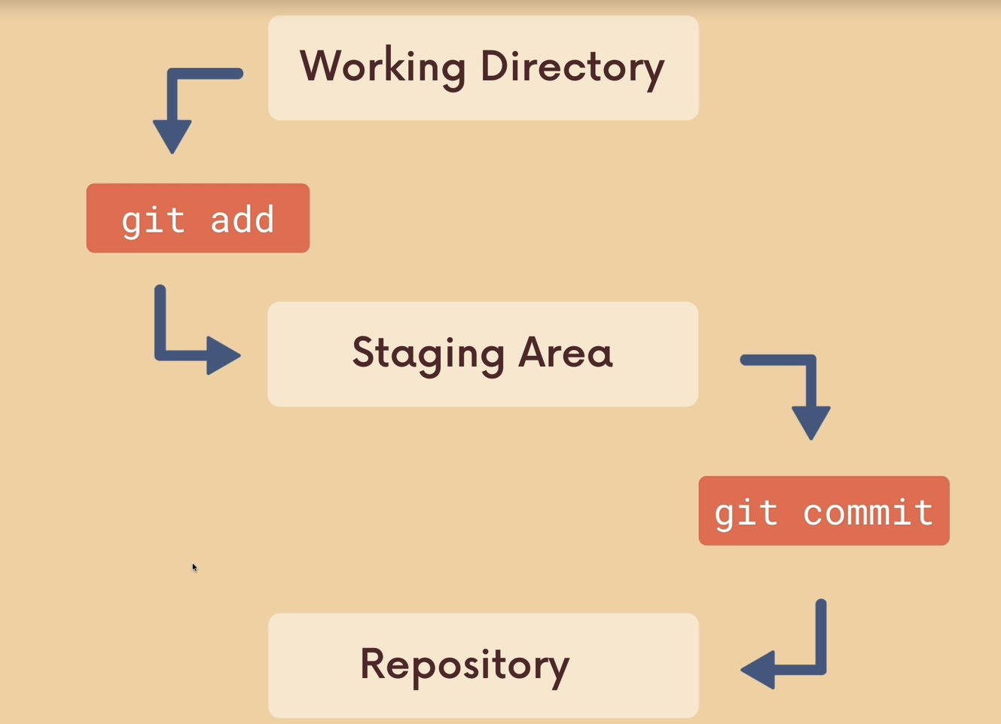

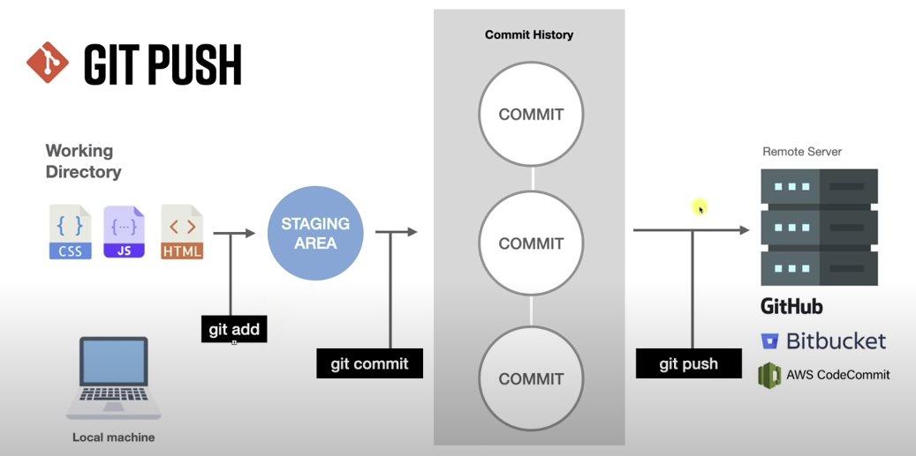

khonj@Khonje-T490s MINGW64 ~/Documents/Repos/MyFirstNovel (main)

$ vi main.go

The above code opens vim editor to edit a document.

Press I for –INSERT—

Enter the details at the top and press escape key to save.

Type at the bottom wq and press enter to return to the main console

khonj@Khonje-T490s MINGW64 ~/Documents/Repos/MyFirstNovel (main)

$ git status

On branch main

Your branch is up to date with 'origin/main'.

Untracked files:

(use "git add <file>..." to include in what will be committed)

main.go

nothing added to commit but untracked files present (use "git add" to track)

khonj@Khonje-T490s MINGW64 ~/Documents/Repos/MyFirstNovel (main)

$ git add .

warning: LF will be replaced by CRLF in main.go.

The file will have its original line endings in your working directory

khonj@Khonje-T490s MINGW64 ~/Documents/Repos/MyFirstNovel (main)

$ git status

On branch main

Your branch is up to date with 'origin/main'.

Changes to be committed:

(use "git restore --staged <file>..." to unstage)

new file: main.go

khonj@Khonje-T490s MINGW64 ~/Documents/Repos/MyFirstNovel (main)

$ git commit -m "Aded main.go with empty main function"

[main 4b6d381] Aded main.go with empty main function

1 file changed, 1 insertion(+)

create mode 100644 main.go

khonj@Khonje-T490s MINGW64 ~/Documents/Repos/MyFirstNovel (main)

$ git log

commit 4b6d3818dedf21ad69e0746401931e66200ea85d (HEAD -> main)

Author: James <khonjeja@gmail.com>

Date: Sat Dec 18 16:47:24 2021 +0000

Aded main.go with empty main function

commit 5d974226f899ceb4f710c7b703ea2a7b871c86ab (origin/main)

Author: James <khonjeja@gmail.com>

Date: Sat Dec 18 15:11:45 2021 +0000

New 3 files added

commit 8c8ace4146980ea9444765d1d4c577d92750a022

Author: James <khonjeja@gmail.com>

Date: Sat Dec 18 14:44:06 2021 +0000

Added chapter2

Changed information

commit fcc43a2852a49ce08f1a31d1b87f09e7e5cc2264

Author: James <khonjeja@gmail.com>

Date: Sat Dec 18 14:30:51 2021 +0000

Keep Commits atomic

commit a22546418c1f754d1716961d661851e332d21e61

Author: James <khonjeja@gmail.com>

Date: Sat Dec 18 14:12:25 2021 +0000

Begin work on Chapter1

commit a5485230b38e54b711c644d42425faad47dae26b

Author: James <khonjeja@gmail.com>

Date: Sat Dec 18 14:09:55 2021 +0000

Begin work on Chapter1

commit 7cec60f8b0724e04be3e764e70adbfb0f225f941

Author: James <khonjeja@gmail.com>

Date: Sat Dec 18 14:03:09 2021 +0000

My Book Outline and Main Characters

khonj@Khonje-T490s MINGW64 ~/Documents/Repos/MyFirstNovel (main)

$ git push

Enumerating objects: 4, done.

Counting objects: 100% (4/4), done.

Delta compression using up to 8 threads

Compressing objects: 100% (2/2), done.

Writing objects: 100% (3/3), 296 bytes | 296.00 KiB/s, done.

Total 3 (delta 1), reused 0 (delta 0), pack-reused 0

remote: Resolving deltas: 100% (1/1), completed with 1 local object.

To https://github.com/khonjeja2021/MyFirstNovel.git

5d97422..4b6d381 main -> main

khonj@Khonje-T490s MINGW64 ~/Documents/Repos/MyFirstNovel (main)

$ git log

commit 4b6d3818dedf21ad69e0746401931e66200ea85d (HEAD -> main, origin/main)

Author: James <khonjeja@gmail.com>

Date: Sat Dec 18 16:47:24 2021 +0000

Aded main.go with empty main function

commit 5d974226f899ceb4f710c7b703ea2a7b871c86ab

Author: James <khonjeja@gmail.com>

Date: Sat Dec 18 15:11:45 2021 +0000

New 3 files added

commit 8c8ace4146980ea9444765d1d4c577d92750a022

Author: James <khonjeja@gmail.com>

Date: Sat Dec 18 14:44:06 2021 +0000

Added chapter2

Changed information

commit fcc43a2852a49ce08f1a31d1b87f09e7e5cc2264

Author: James <khonjeja@gmail.com>

Date: Sat Dec 18 14:30:51 2021 +0000

Keep Commits atomic

commit a22546418c1f754d1716961d661851e332d21e61

Author: James <khonjeja@gmail.com>

Date: Sat Dec 18 14:12:25 2021 +0000

Begin work on Chapter1

commit a5485230b38e54b711c644d42425faad47dae26b

Author: James <khonjeja@gmail.com>

Date: Sat Dec 18 14:09:55 2021 +0000

Begin work on Chapter1

commit 7cec60f8b0724e04be3e764e70adbfb0f225f941

Author: James <khonjeja@gmail.com>

Date: Sat Dec 18 14:03:09 2021 +0000

My Book Outline and Main Characters

khonj@Khonje-T490s MINGW64 ~/Documents/Repos/MyFirstNovel (main)

$ ls

Chapter1.txt MoodBoard/ index.html main.css outline.txt

Chapter2.txt characters.txt index.js main.go

khonj@Khonje-T490s MINGW64 ~/Documents/Repos/MyFirstNovel (main)

$ git pull

remote: Enumerating objects: 7, done.

remote: Counting objects: 100% (7/7), done.

remote: Compressing objects: 100% (5/5), done.

remote: Total 6 (delta 2), reused 0 (delta 0), pack-reused 0

Unpacking objects: 100% (6/6), 1.37 KiB | 43.00 KiB/s, done.

From https://github.com/khonjeja2021/MyFirstNovel

4b6d381..a9bafcd main -> origin/main

Updating 4b6d381..a9bafcd

Fast-forward

README.md | 3 +++

1 file changed, 3 insertions(+)

create mode 100644 README.md

khonj@Khonje-T490s MINGW64 ~/Documents/Repos/MyFirstNovel (main)

$ ls

Chapter1.txt MoodBoard/ characters.txt index.js main.go

Chapter2.txt README.md index.html main.css outline.txt

khonj@Khonje-T490s MINGW64 ~/Documents/Repos/MyFirstNovel (main)

$ cat main.go

func main() {}

khonj@Khonje-T490s MINGW64 ~/Documents/Repos/MyFirstNovel (main)

$ git pull

remote: Enumerating objects: 5, done.

remote: Counting objects: 100% (5/5), done.

remote: Compressing objects: 100% (2/2), done.

remote: Total 3 (delta 1), reused 0 (delta 0), pack-reused 0

Unpacking objects: 100% (3/3), 667 bytes | 39.00 KiB/s, done.

From https://github.com/khonjeja2021/MyFirstNovel

a9bafcd..f554f74 main -> origin/main

Updating a9bafcd..f554f74

Fast-forward

main.go | 2 ++

1 file changed, 2 insertions(+)

khonj@Khonje-T490s MINGW64 ~/Documents/Repos/MyFirstNovel (main)

$ cat main.go

package main

func main() {}

khonj@Khonje-T490s MINGW64 ~/Documents/Repos/MyFirstNovel (main)

$

**Branches – used video**

There are different branches and the main one is called the Main Branch.

New branches can be created as a copy of the existing Main branch

khonj@Khonje-T490s MINGW64 ~/Documents/Repos/MyFirstNovel (main)

$ git branch - Show the current branch

* main

khonj@Khonje-T490s MINGW64 ~/Documents/Repos/MyFirstNovel (main)

$ git branch -r

origin/main

khonj@Khonje-T490s MINGW64 ~/Documents/Repos/MyFirstNovel (main)

$ git branch -a - List all branches in repo

* main

remotes/origin/main

khonj@Khonje-T490s MINGW64 ~/Documents/Repos/MyFirstNovel (main)

$ git branch feature-a Coe used to create a new branch

khonj@Khonje-T490s MINGW64 ~/Documents/Repos/MyFirstNovel (main)

$ git branch -a

feature-a

* main

remotes/origin/main

khonj@Khonje-T490s MINGW64 ~/Documents/Repos/MyFirstNovel (main)

$ git checkout feature-a

Switched to branch 'feature-a'

khonj@Khonje-T490s MINGW64 ~/Documents/Repos/MyFirstNovel (feature-a)

$ git branch -a

* feature-a

main

remotes/origin/main

khonj@Khonje-T490s MINGW64 ~/Documents/Repos/MyFirstNovel (feature-a)

$ git checkout - - Used to change branch one is using

Switched to branch 'main'

Your branch is up to date with 'origin/main'.

khonj@Khonje-T490s MINGW64 ~/Documents/Repos/MyFirstNovel (main)

$ git branch -a

feature-a

* main

remotes/origin/main

khonj@Khonje-T490s MINGW64 ~/Documents/Repos/MyFirstNovel (main)

$

**Push Branch to github**

khonj@Khonje-T490s MINGW64 ~/Documents/Repos/MyFirstNovel (main)

$ git checkout -

Switched to branch 'feature-a'

khonj@Khonje-T490s MINGW64 ~/Documents/Repos/MyFirstNovel (feature-a)

$ git push

fatal: The current branch feature-a has no upstream branch.

To push the current branch and set the remote as upstream, use

git push --set-upstream origin feature-a

khonj@Khonje-T490s MINGW64 ~/Documents/Repos/MyFirstNovel (feature-a)

$ git push --set-upstream origin feature-a

Total 0 (delta 0), reused 0 (delta 0), pack-reused 0

remote:

remote: Create a pull request for 'feature-a' on GitHub by visiting:

remote: https://github.com/khonjeja2021/MyFirstNovel/pull/new/feature-a

remote:

To https://github.com/khonjeja2021/MyFirstNovel.git

* [new branch] feature-a -> feature-a

Branch 'feature-a' set up to track remote branch 'feature-a' from 'origin'.

Deleting a Branch. First we create a new branch named to-delete

khonj@Khonje-T490s MINGW64 ~/Documents/Repos/MyFirstNovel (feature-a)

$ git checkout main

Switched to branch 'main'

Your branch is up to date with 'origin/main'.

khonj@Khonje-T490s MINGW64 ~/Documents/Repos/MyFirstNovel (main)

$ git checkout -b to-delete

Switched to a new branch 'to-delete'

khonj@Khonje-T490s MINGW64 ~/Documents/Repos/MyFirstNovel (to-delete)

$ git branch -a

feature-a

main

* to-delete

remotes/origin/feature-a

remotes/origin/main

khonj@Khonje-T490s MINGW64 ~/Documents/Repos/MyFirstNovel (to-delete)

$ git checkout -

Switched to branch 'main'

Your branch is up to date with 'origin/main'.

khonj@Khonje-T490s MINGW64 ~/Documents/Repos/MyFirstNovel (main)

$ git branch -d to-delete

Deleted branch to-delete (was f554f74).

khonj@Khonje-T490s MINGW64 ~/Documents/Repos/MyFirstNovel (main)

$ git branch -a

feature-a

* main

remotes/origin/feature-a

remotes/origin/main

khonj@Khonje-T490s MINGW64 ~/Documents/Repos/MyFirstNovel (main)

$

Branching video stopped at 1:20:00